Super MP5 Player
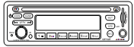
Single Disk Car DVD Player
JA923DSH User Manual

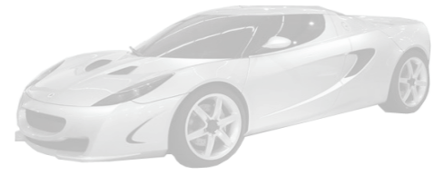
Statement
All rights reserved.
No part of this manual may be reproduced or spread, in any form or by any means, without written permission from this Company.

This user manual is subject to update without prior notice as the product is updated from time to time. It can only be used as operation instructions, if not agreed otherwise. All the statements, information and suggestions in this user manual do not constitute a warranty of any kind, expressed or implied.
Catalog

Product Overview 1
Panel Function Description 2-4
Remote Control Function Description 5-14
Precautions 15
Common Troubles and Trouble-shooting Methods 16
Installation Guide of Main Unit 17
Comprehensive Parameters 18
Packing List 19

1. Product Overview
- 1 DIN standard installation size
- Programs in the formats such as RMVB/RM/MP3/VCD/MP4/VOB/MPG/AVI/JPG/DVD can be played.
- Stationary panel
- NTSC/PAL double system compatible
- Power failure, breakpoint memory
- Full function remote control
- Built-in radio FM/AM radio
- Auto search and save channels
- EQ sound effects control
- Stereo, left channel and right channel selection
- Maximum output power: 4*45W
- Two-channel video output
- Two-channel audio output
- Two-channel audio input (built-in backup)
- External Karaoke input (out of control of the master volume)
- Adjustable microphone
- Support to play one-channel SD card
- Support external laptop hard drive
(support laptop hard drive, less than 160GB (including 160GB) with 2.5 feet of SATA port)
- Support to play HD-image program
- Create folders in HDD/SD card: create many a folder such as movies and music under the root directory; put the programs to play into corresponding folders;

2. Panel Function Description
2.1 Panel Function Button

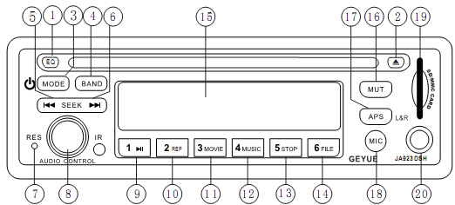

2.2 Appearance of Overall Unit and Basic Functions of Buttons
1. EQ: press it to switch the sound effect among Class, Rock and Pop.
2. Eject button (): press it to pop out the disk.
3. MODE button: you can press it to turn on the player and switch the mode among Radio, DVD, HDD and SD card while long press it to turn off the player.
4. BAND button: press it to switch among radio FM1, FM2 and FM3.
5. button (SEEK): in Radio mode, press it to scan automatically towards low frequency. In Play mode, short press it to switch to the Previous Track and long press it to perform fast back (back ×2, ×4, × 8).
6. button (SEEK): in Radio mode, press it to scan automatically towards high frequency. In Play mode, short press it to switch to the Next Track and long press it to perform fast forward (speed ×2, ×4, ×8).
7. RES (reset key): press this button to restore the machine to the factory settings.
8. AUDIO CONTROL button: adjust this knob to change volume; long press it to enter clock adjustment mode and long press again (until clock flickers) to enter clock adjustment status; when pressing SEEK to adjust clock parameters, you can press AUDIO CONTROL to enter SEL function and you can select audio regulation mode in the order below:

Volume
Bass
Front & Rear Channel
Treble
Left & Right Channel
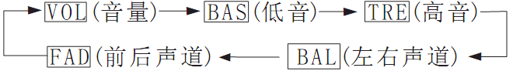
9. Radio prestore 1/Playback pause button ():
In radio reception, short press it to play on the radio channel saved in radio station 1; when on the radio, long press it to save the current radio channel to radio station 1. In disk playing, short press it to pause and press it again to resume playing; in case of speed/back, press it to play. In case SETUP settings menu is open: press it to confirm.
10. Radio prestore 2/Set key (2REP):
In radio reception, short press it to play on the radio channel saved in radio station 2; when on the radio, long press it to save the current radio channel to radio station 2. In disk playing, press it and directly enter to switch the playback mode: repeat one, repeat all and loop.
11. Radio prestore 3/MOVIE play shortcut key: (3MOVIE):
In radio reception, short press it play on the radio channel saved in radio station 3; when on the radio, long press it to save the current radio channel to radio station 3. When playing HDD/SD card, short press it to directly enter movie playback (in case of DVD playback/manual mode, this key doesn’t work).
12. Radio prestore 4/MUSIC play shortcut key: (4MUSIC):
In radio reception, short press it play on the radio channel saved in radio station 4; when on the radio, long press it to save the current radio channel to radio station 4. When playing HDD/SD card, short press it to directly enter music playback (in case of DVD playback/manual mode, this key doesn’t work).
13. Radio prestore 5/STOP play shortcut key: (5STOP):
In radio reception, short press it play on the radio channel saved in radio station 5; when on the radio, long press it to save the current radio channel to radio station 5. In disk playing, short press it to stop.
14. Radio prestore 5/FILE play shortcut key: (6FILE):
In radio reception, short press it play on the radio channel saved in radio station 6; when on the radio, long press it to save the current radio channel to radio station 6. In disk playing, short press it to enter folder selection (in case of DVD playback/automatic mode, this key doesn’t work).
15. LCD panel: display the information of the current system.
16. MUT button: press it to make the machine mute and press it again to unmute; in the status of MIC, press this button to enter Karaoke mode (play background music).
17. APS (L/R) button: in radio reception, press it and the machine will search and save channel automatically; in playback, short press it to switch the sound channel: stereo, left and right, while long press it to switch the TV system (PAL and NTSC).
18. MIC button: press it to enter microphone function and LCD panel displays the microphone sign (notes: only when microphone is inserted to this machine, can this button work).
1) When pressing MIC button: AUDIO CONTROL adjusts the volume of microphone and other parameters. Press this button to enter MIC function selection and you can select MIC VOL and EAHO (reverberate).
Special note: in case microphone is not inserted, MIC button on the panel doesn’t work; but when microphone is inserted (switch on or off), this button works and now a microphone sign displays on the panel; this moment you can adjust the volume of MIC and the reverberation depth and also you can mute the player or radio. When Karaoke is needed, press MUTE to unmute the player.
19. SD card connector: insert SD card here.
20. MIC JACK: microphone input jack.

3. Remote Control Function Description
3.1 Remote Control Buttons Description
- Basic Functions of Remote Control Buttons
1.POWER
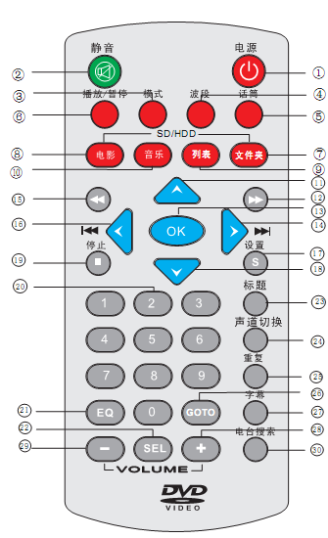
2. MUTE
3. MODE
4. BAND
5. MIC (microphone)
6. PLAY/PAUSE
7. FILE
8. MOVIE
9. LIST
10. MUSIC
11. Select upwards
12. SPEED
13. OK
14. SEEK+
15. BACK
16. SEEK-
17. SETUP
18. Select downward
19. STOP
20. 0~9
21. EQ ( Equalizer)
22. SEL
23. TITLE
24. L/R (left/right channel)
25. REP (repeat)
26. GOTO
27. TITLE
28. VOL+
29. VOL-
30. APS (automatic program search)

3.2 Basic Function Introductions of Remote Control Buttons
1. POWER:
Short press this button to power off and any key to power on.
2. MUTE:
Press the MUTE key on the panel or on the remote control to disable volume, that is, to mute the sound; press it again to unmute. Note: in case of mute, a mute sign will appear on the screen.
3. MOD:
Press MODE, the machine switches mode among radio, DVD, HDD AND SD card. The sign of the currently playing device appears on the screen of main unit. For example, when playing hard drive, HDD appears on the screen; When playing SD card, SD appears.
4. BAND:
Press this button to switch band among FM1, FM2 and FM3.5.
5. MIC:
Press this button to select: MIC VOL (volume regulation option) and EAHO (reverberation regulation option).
6. PAUSE/PLAY:
When playing DVD/HDD/SD card: press on the remote control to pause the playing program, and press again to resume playing. In case of Speed/Back, press this button to resume normal playback.
7. FILE:
When playing SD card and HDD, press this button to directly enter the root directory of file folder.
(In case of DVD, this button doesn’t work).
8. MOVIE:
In the status of playback, press this button to directly enter movie playback; (In case of DVD, this button doesn’t work).
9. LIST:
In the status of playback, press this button to directly enter list and select to play; (In case of DVD, this button doesn’t work).
10. MUSIC:
In the status of playback, press this button to directly enter music playback; (In case of DVD, this button doesn’t work).
11. Select upward button
In case of file folder option and settings menu option, you can move the cursor upwards to select the item.
12. SPEED
In the status of playback, press this button to enter speed play (×2, ×4, ×8), adjust to speed ×8, and then press this button to resume the normal speed.
13. OK
In case of file folder option and settings menu option, press it to confirm the option where the cursor stays.
14. SEEK+
In the status of playback, press this key to play next track; in case of file folder option and settings menu, you can press it to move the cursor rightward to select the item; after press OK, you can adjust the parameters upwards; in case of clock adjustment, you can adjust the time upwards.
15. BACK
In the status of playback, press this button to perform Back Play (×2, ×4, ×8), adjust to back ×8, and then press this button to resume the normal speed.
16. SEEK-
In the status of playback, press this key to play the previous track; in case of file folder option and settings menu, you can press it to move the cursor leftward to select the item; after press OK, you can adjust the parameters upwards; in case of clock adjustment, you can adjust the time downwards.
17. SETUP
In the status of pause, you can press this button to enter the setting menu directly, including:

17.1 General Settings page
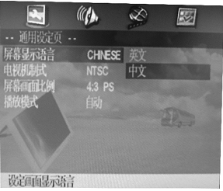
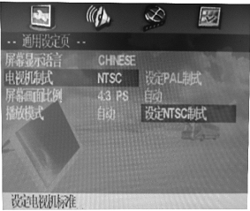

17.1.1 Set language displayed on the screen 17.1.2 Set video system
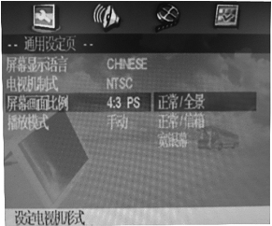
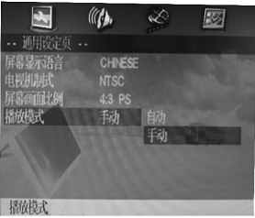

17.1.3 Set aspect ration displayed on the screen 17.1.4 Set playback mode, note:
Under manual mode, there is no playback memory function.
Under automatic mode, there is playback memory function.

17.2 Analog Audio Settings page
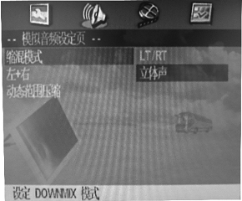
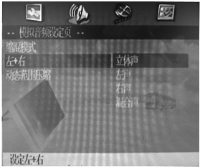

17.2.1 Set DOWNMIX Mode 17.2.2 Set Left/Right/Stereo/Mixdown switch
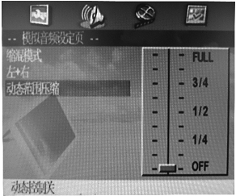

17.2.3 Audio dynamic range compression settings

Note: since this item has been set to optimum value at the factory, regulation is not required in general.

17.3 Video Settings page
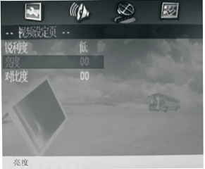
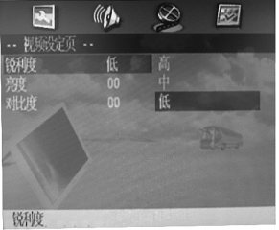

17.3.1 Set sharpness displayed on the screen 17.3.2 Set brightness displayed on the screen
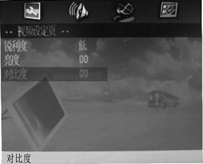

17.3.3 Set contrast displayed on the screen

Note: since this item has been set to optimum value at the factory, regulation is not required in general.
17.4 Initial Settings page
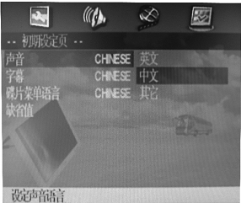
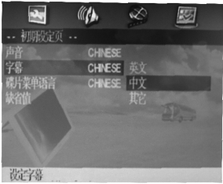

17.4.1 Set the language of sound (media files must be in multiple languages)

17.4.2 Set the subtitle language (media files must be in multiple languages)

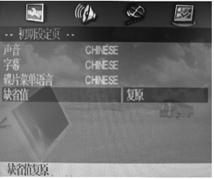
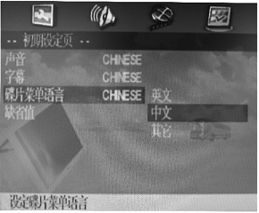

17.4.3 Set the language displayed on the disk menu (media files must be in multiple languages)

17.4.4 Restore to default settings

18. Select downward
In case of file folder option and settings menu, you can move the cursor downward to select the item;
19. Stop playing
In the status of playing, press Stop on the remote control, then the program stops and the image stops at the interface of the playing program.
20. 0~9
1. In the status of radio reception: short press 1~6 to play on the radio channel saved in the corresponding radio station; in case of radio channel search, long press it to save the current radio channel to the corresponding radio station;
2. When playing, press it to select a track directly. For the track number equal to 10 or larger than 10, fast press the number of the track. For example, the track number is 25. You shall press 2 first and then 5 and press OK; others follow that.
21. EQ
Press this button to adjust sound effects: classic, pop, rock, etc.
22. SEL
Press this button and you can select the left/right/front/rear balance and bass/treble regulation options of the speaker.
23. TITLE
In the status of DVD playback, press this button to enter track list directly;
24. L/R
In the status of playing, press this button to switch the sound channel among left, right and stereo;
25. REP
In the status of playing, press this button to repeat the current song (external screen displays: REP), press it again to repeat all the song (external screen displays: ALLREP); then press it again to return to normal.
26. GO TO
In the status of playing, press this key and you can skip to play.
27. TITLE
In the status of playing, press this button to switch the title language directly.

28. VOL+
Press this button to increase the volume of the player.
29. VOL-
Press this button to lower the volume of the player.
30. APS
In the status of reception, you can press this button to enter “Auto search and save radio station”;
3.3 Precautions for Using Remote Control:
1. This device can only use two 7# 1.5V batteries.
2. Under normal circumstances, battery can be used for about 6 months. In case the remote control cannot work, please replace the battery in time.
3. If the remote control is not used for a long period of time, please take out the battery from it to avoid deterioration of the battery.
4. Do not expose the remote control to high temperature or direct sunlight, otherwise it may not work normally.
5. In case of battery installation, please make sure you fit the positive pole (+) and negative pole (-) properly.
6. Please follow the figure below to install the battery (ADD assembly diagram).

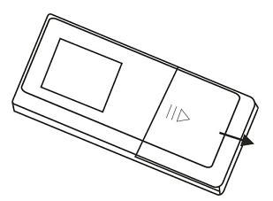

4. Precautions
☆ In case of installation, keep it on a level surface and make sure normal heat dissipation of the player. Do not block the ventilation opening of the player and place the player over 5cm away from other devices for better heat dissipation;
☆ Keep the player away from these places below:
- Places exposed to direct sunlight or near radiation machine (such as heater);
- On the top of heat radiating objects;
- Place of poor ventilation or with plenty of dust (keep its shell clean)
- Humid area or place exposed to rain;
☆ You have to use power supply voltage correctly and any power other than as specified can absolutely not be used. Refer to connection direction carefully prior to turning on the power. Make sure all the connection wires are connected properly and do not touch power and player with wet hands;
☆ Do not spill liquid and scatter metal chip on the player to avoid internal short to the machine;
☆ Moisture condensation may be caused if the player is moved from a colder place to a warmer one suddenly. At that moment, do not turn it on to avoid internal short;
☆ Do not place any other device directly on this player;
☆ Non-professionals are not allowed to remove the machine shell. Please contact the local service center for maintenance;
☆ This player requires DC 12V power supply. Please check if your car battery meets the requirements prior to installation. Reverse pole connection is absolutely not allowed. If the output voltage of your car is DC 24V (large car), please connect a DC-DC buck regulator; if it is DC 12V, a buck regulator is not necessary;
☆ For you safety, please do not adjust the volume too high， or you cannot hear outside, which increases the risk in driving. In case of complex operations, you shall stop your car in a safe area first;
☆ This player is suitable to work at the temperature between -10 ℃ and 80 ℃. If it can not work below -10 ℃, you can press the power button to preheat it for 5 to 10 minutes; then power it off and power it on again, you can restore it to normal function.

5. Common Troubles and Trouble-shooting Methods
Troubles | Reasons | Trouble-shooting Methods
No power supply | Polarity reversed | Check if the power cord is connected properly
No power supply | Fuse burnt | Replace fuse
No sound | Volume not enabled | Adjust volume switch
No sound | Improper connection of speaker | Check the circuit and properly connect it
No sound | Machine is mute | Disable mute
Unsteady image | Improper connection of video | Check it and properly connect
Image without color | System error | Adjust to right system
Buttons don’t work | Master control IC program is out of order | Press RESRT to restore and power it on again
Poor radio | Antenna problems | Adjust the antenna and make it grounding
Poor radio | Weak signal | Change the channel again
System halted | Unsteady voltage and current enable automatic protection of master program | Power it off, wait for 10 seconds and power it on again
Remote control doesn’t work | Battery of remote control depleted | Replace the battery

Note: if fault remains after troubleshooting, please turn to professionals or dealer for help and do not repair it by yourself.

6. Installation Guide of Main Unit
6.1 Installation Guide
Note: before installation, please turn off the power and switch off this player and do not power it on unless it is connected properly.
1. First fit the mounting ring of the machine to the instrument panel of car properly. Cautions: the baffle plate of the mounting ring shall be bent outwards to insert into the instrument panel.
2. Put the machine into the mounting ring until most parts of the machine remains in the frame (maximum level angle: 30°)
3. Connect the ground wire of battery to make sure an optimum working state for the machine.
4. Insert the machine to mounting ring until it fits to the bottom of the frame properly and its sides closely contact the frame.
6.2 Connecting Mode
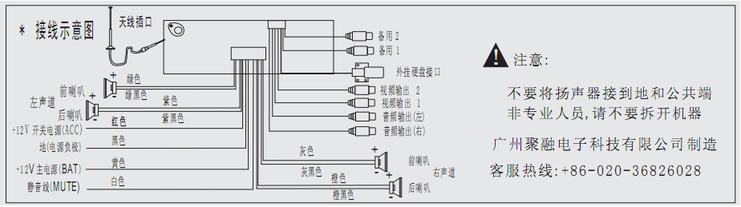

Connection Diagram
Front speaker
Rear speaker
Left channel
Green
Green black
Purple
Antenna Jack
Backup 2
Backup 1
External hard disk port
Video output 2
Video output 1
Notice:
Do not connect speaker to ground and common port
Non-professionals are not allowed to take apart machine

Made by Guangzhou Jurong Electronic Technology Co., Ltd.
Customer hotline: + 86-020-36826028
Red
+12V switch power (ACC)
+12V main power (BAT)
Mute wire (MUTE)
Black
Yellow
White

Dark grey
Grey
Orange
Black orange
Audio output (left)
Audio output (right)
Front speaker
Rear speaker
Right channel
Ground (Power negative pole)
This machine adopts DC 12V power supply, with its negative pole connected to ground (car underframe). It is required that this product shall be firmly connected to chassis, as sound ground can effectively reduce the current noise. When using, please keep this product from dust and dirt and make sure excellent electrical connection. The speaker is 4 to 8 ohm.
6.3 Disassembly Instructions

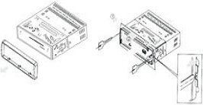
1. Use the key offered with this machine and remove the machine from mounting rack.
2. As shown in the figure on the right, insert the key to the front mounting hole, press the left and right spring sheet to take out the machine.

7. Comprehensive Parameters
7.1 Comprehensive Parameters
Power -------------------------------------------------------12VDC (10V-14.4V)
Fuse ----------------------------------------------------------10A
Installation Size ---------------------------------------------182 (L) × 165 (W) × 52 (H) mm
Panel Size -----------------------------------------------------188 (L) × 165 (W) × 58 (H) mm
Temperature Range of Working Condition ---------------- -10℃ ~ 80℃
Grounding mode ----------------------------------------------- Negative ground
7.1.1. Power Amplifier
Maximum output power --------------------------------------- 4 × 45W
Continuous power output --------------------------------------- 4 × 25W
Resistance -------------------------------------------------------- 4 Ohm
7.1.2. FM Tuning
Tuning range ---------------------------------------------------87.5 – 108 MHz (50KHz)
Intermediate frequency --------------------------------------- 10.7 MHz
SNR ------------------------------------------------------------- 55dB
Stereo crosstalk ------------------------------------------------ 30 dB
Frequency response ------------------------------------------- 30 – 15,000Hz

8. Packing List
No. | Material Name | Number | Unit | Notes
1 | Main unit | 1 | Set
2 | Mounting ring of main unit | 1
3 | Key for removal | 1 | Pair
4 | Mounting strip | 1 | Piece
5 | Power cord/speaker wire | 1 | Piece
6 | Hard drive box | 1 |  | Optional
7 | USB cable | 1 | Piece | Optional
8 | User manual | 1
9 | Warranty card | 2 | Piece
10 | Certificate of Quality | 1 | Piece

Notes: The configurations on the list above are subject to changes without prior notice. This company reserves the final right to interpret. Sorry for any inconvenience caused.

Manufacturer: Guangzhou Jurong Electronic Technology Co., Ltd.
Address: Hi-tech Development Zone, Huadu District, Guangzhou, Guangdong
Customer Hotline: 86-020-36826028

